SELF-ACTUALIZATION AND TRANSCENDENCE
Greenville UU Fellowship
Covenant Group Session Plan

Welcome, Chalice Lighting: We are here to follow the promptings of our deepest heart. We are here with expectations, alive, spoken and unspoken. We are here because we are human. Creatures of Solitude and communion. Wanting wholeness, knowing brokenness. We meet here once again to remind ourselves of what we already know. We open ourselves to word, story, song. To whatever breaks in upon us or summons us to speak or act. Our time together affects our time apart. We want to participate, to be known, to be loved. We know limits, yet so much is possible. ~ Mark Belletini

Personal Check In: Share something from your life since we last met and how you are feeling now.

Opening Reading:
To be fully self-actualized, you must transcend your self. ~Paraphrased from sermon by Reverend Pat Jobe, sermon given on June 26, 2016.

To courageously step through fear and pain and loneliness is to step into transcendence. ~Amy Larsen

Questions to prompt and guide discussion:
- How can we transcend our own self?
- Describe a time when you felt awe.
- Which of Maslow’s needs do you feel you’ve met?
- Which of the needs in Maslow’s hierarchy do you struggle to have met?
- What do you think Simone Weil means when she says: “Contradiction is the lever of transcendence”
- Describe any experience you’ve had with practicing meditation.

Readings:
Self-Transcendence: The sincere seeker accepts the world as his/her own. Like a potter who accepts clay and molds it into something beautiful, the spiritual seeker accepts the life of ignorance and tries to transform it with his/her inner wisdom light. ~Sri Chinmoy

Disassociating, mindfulness, transcendence -- whatever the label -- it’s a sort of loophole in our contract with reality, a form of self-rescue. ~Diane Ackerman

Individual transcendence collectively inspires humanity at large. ~Sri Chinmoy

Self-actualization cannot be attained if it is made an end in itself, but only as a side effect of self-transcendence. ~Viktor Frankl

Transcending the world does not mean to withdraw from the world, to no longer take action or to stop interacting with people. Transcendence of the world is to act and interact without any self-seeking.
~Eckhart Tolle

Awe is the emotion of self-transcendence. ~Jonathon Haidt

Transcendence is the only real alternative to extinction. This is serious. This may be our final exam.
~Joel Garreau

I remember after a particular run feeling so immensely satisfied, cleansed and whole. It was as if I’d been somewhere else. I’d visited a boundless timeless world where movement was so effortless, it seemed I could run forever. ~Anonymous

Contradiction is the lever of transcendence. ~Simone Weil

Soul transcendence is a simple path. There is nothing extraordinary you need to do. Simply open your awareness to all that is around you, and within you, and follow the loving. ~John-Roger with Pauli Sanderson

Sharing: Deep listening--no cross talk. Everyone has a chance to speak once before anyone speaks twice. Each person shares as she feels ready, and it is OK to pass. When others speak, do not respond with words. Attentive body language, listening deeply and accepting what they are saying without thinking how you want to react are ways to honor our covenant to each other.

Sit in Silence to Reflect on Thoughts Shared

Open Discussion: (Cross talk allowed) During this time, everyone shares freely, enlarging on and reacting to others’ ideas. Be careful not to interrupt or “fixing, saving, advising, or setting someone straight.”

Personal Check Out:
How would you like to be held in heart and mind before we meet again?

Closing Readings:
Go out into the world with new eyes and open hearts. Seek awe in unlikely places. ~Anonymous
Announcements / Plans

Extinguish the Chalice

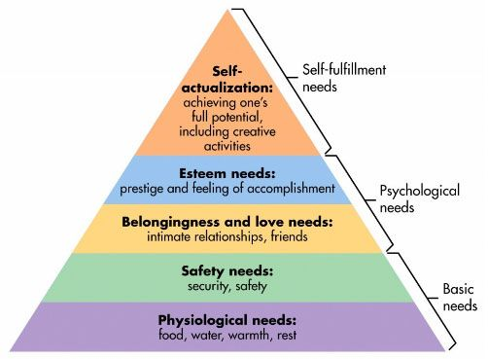
Maslow’s Hierarchy of Needs, http://www.simplypsychology.org/maslow.html

